Classroom Connection Activities

Please engage in the following activities and bring resulting responses or materials with you to our next session. Feel free to engage with colleagues in these activities, however it will be helpful for each participant to bring or upload responses and materials for the next session.

- In sessions 2 and 3, you explored a series of representations of $\frac{3}{4}$.

  - Examine whether the working definition of a fraction that was developed in Session 3 can be used to explain the following representations of $\frac{3}{4}$. The working definition of a fraction can be found in the Resource Library for Session 3. Record any limitations you notice with the working definition.

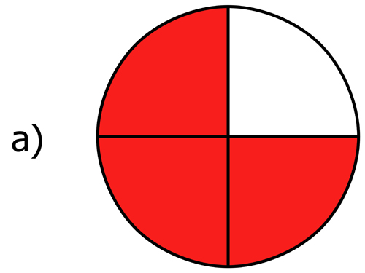 | 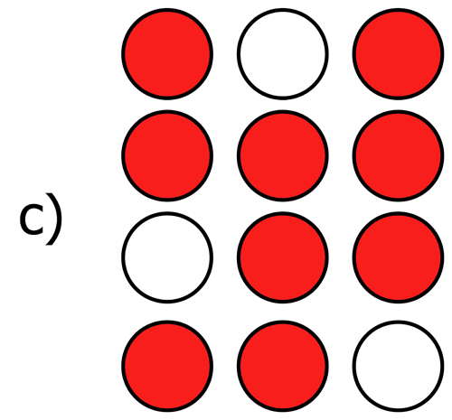 | 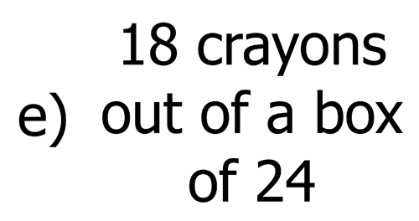 | 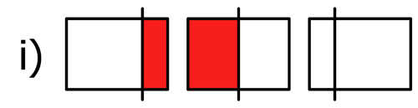

  - In Session 3, you worked on connecting different representations. Talk through (narrate) the connection between the following pairs of representations:
- a and i
- c and e
In your narration, try using the ideas of “whole” or “fourths”, or the number 3, to support the connection you make between the representations.

- In our next session, we will focus on the number line representation. In preparation for this discussion, make notes in response to the following two questions.

  - What are important properties of the number line?

  - When or how have you used number lines in your teaching?

Optional

- The importance of definitions and the work of developing definitions was a focus of this session. In the paper, "Definitions and Defining in Mathematics and Mathematics Teaching", Bass and Ball (2009) describe the requirements of a good definition, as well as mathematical instances of definition and instructional situations that precipitate definitions. The information about this reading can be found in the Professional Readings list, that can be accessed by facilitators in the Session 3 Planner.

After you read the paper, consider a mathematics concept that you are currently teaching using these questions:

  - How are you and your students defining that term or concept?

  - If you haven’t already done so, ask each of your students to write a definition

  - Record some of the common points that are raised by students in their definitions and comment on the mathematical and teaching implications of those ideas.

