Classroom Connection Activities

Please engage in the following activities and bring resulting responses or materials with you to our next session. Feel free to engage with colleagues in these activities, however it will be helpful for each participant to bring or upload responses and materials for the next session.

- Examine the ways in which number lines are used in your curriculum materials.

- What topics are addressed using the number line? If comparing fractions is a part of your curriculum, look carefully at how the number line is used.

- How is the number line first introduced? What features of the number line are presented for student learning?

- How and to what extent do these features change as you progress further into the curriculum materials?

- From the number line ideas that we discussed, what features are not presented in the curriculum? Explain why this absence is either appropriate or problematic.

- In this session, we examined important features of the number line and also explored some patterns in students’ thinking about the number line. For each of the tasks below, first locate the number on the number line yourself. Then, look at a student work sample (the student’s writing is shown in thicker blue markings on the number line). Analyze whether the student’s location of the number is correct. Then, anticipate the reasoning that the student may have used to locate the number.

  - Task A
Initial Task: Locate 4 on this number line
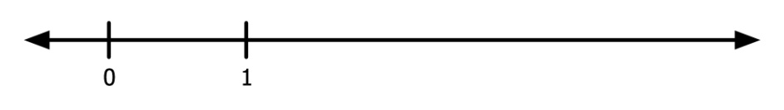
Student work:
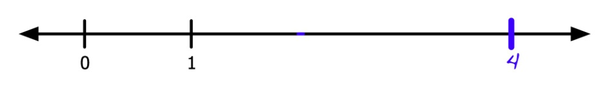

  - Task B
Initial Task: Locate 3 on this number line
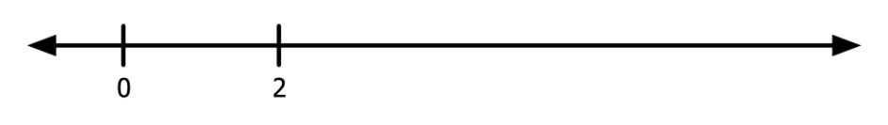
Student work:
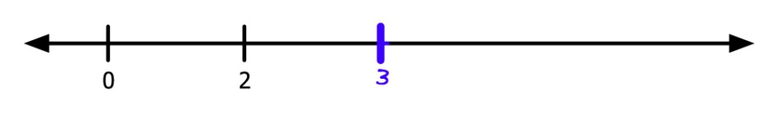

  - Task C

Initial Task: Locate $\frac{1}{6}$ on this number line
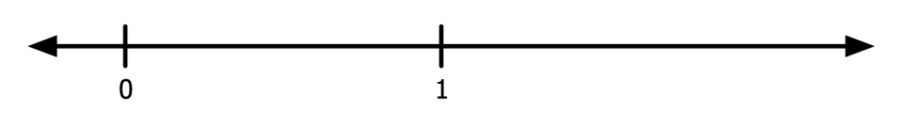
Student work:
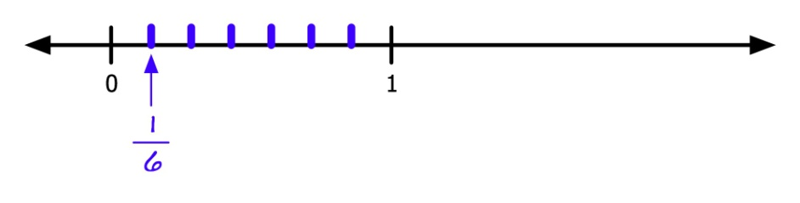

  - Task D
Initial Task: Locate $\frac{4}{5}$
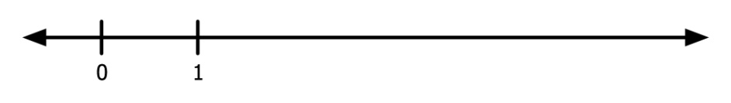
Student work:
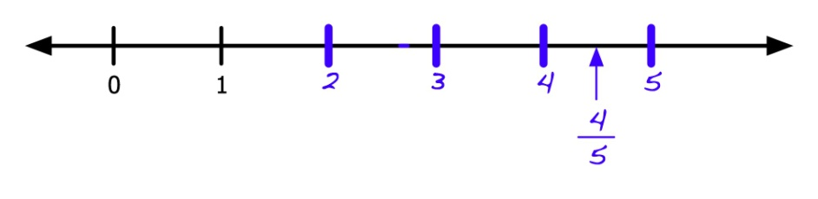

  - Task E
Initial Task: Locate -2
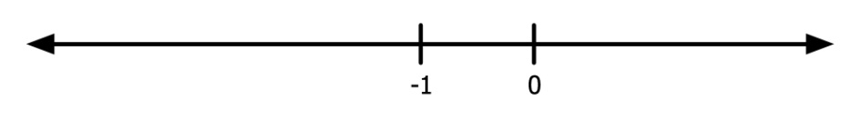
Student work:
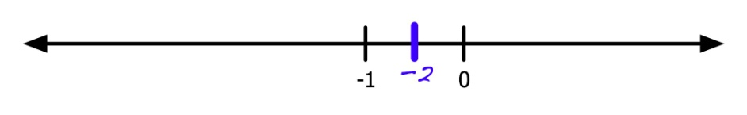

Optional

- Read an excerpt on the number line as a geometric representation of number from the National Research Council (2001) report, Adding It Up: Helping Children Learn Mathematics. The information about this reading can be found in the Professional Readings list, that can be accessed by facilitators in the Session 4 Planner. Notice the ways in which different types of numbers (integers, fractions, etc.) are located on the line as well as how operations with numbers can be modeled using the line.

- Describe how you would use the number line to show that the point midway between 0 and 1 has three different names.

- Describe how you would show fractions with different denominators on the number line(s).

