**Classroom Connection Activity**

Please engage in the following activities and bring resulting responses or materials with you to our next session. Feel free to engage with colleagues in these activities; however, it will be helpful for each participant to (bring or upload) responses and materials for our next session.

1) Complete a subset of the tasks on the following pages—Broken Ruler and new tasks— with 3-4 students of different (hypothesized) achievement levels.

1. Use the anecdotal notes form to support your thinking about which task you will use and how it will allow you to see students’ knowledge and skills with respect to particular learning trajectory levels.
2. Administer the tasks. Ask the students to write down and/or draw how they measured.
3. Use the anecdotal notes form to record notes about how students engage in the task*.*
4. In preparation for next session, jot some notes that will help you be ready to:
   * 1. Describe the task and the context in which it was used (e.g., grade, reason for selecting this particular student, etc.)
     2. Respond to the following focus questions, with references to specific things the students did and/or said, if possible.

* What levels of thinking were made visible by the tasks?
* What new insights or questions do you have about the learning trajectory levels?
* What “next steps” would you take to support the learning of the students?
  + 1. Think about how could you enhance your next use of anecdotal notes.

2) Bring copies of the tasks you used and your notes to our next session where you will have a chance to share them with a small group of your colleagues.

3) For our next session, bring an example lesson or activity from your curriculum that could be used to support learning about length measurement. For our purposes it doesn’t have to be an activity that you think is particularly strong, but rather just a sample from your curriculum.

*Setup:* Place several objects of different lengths on the table. Refer child to objects on desk.

Here’s an example of what we used: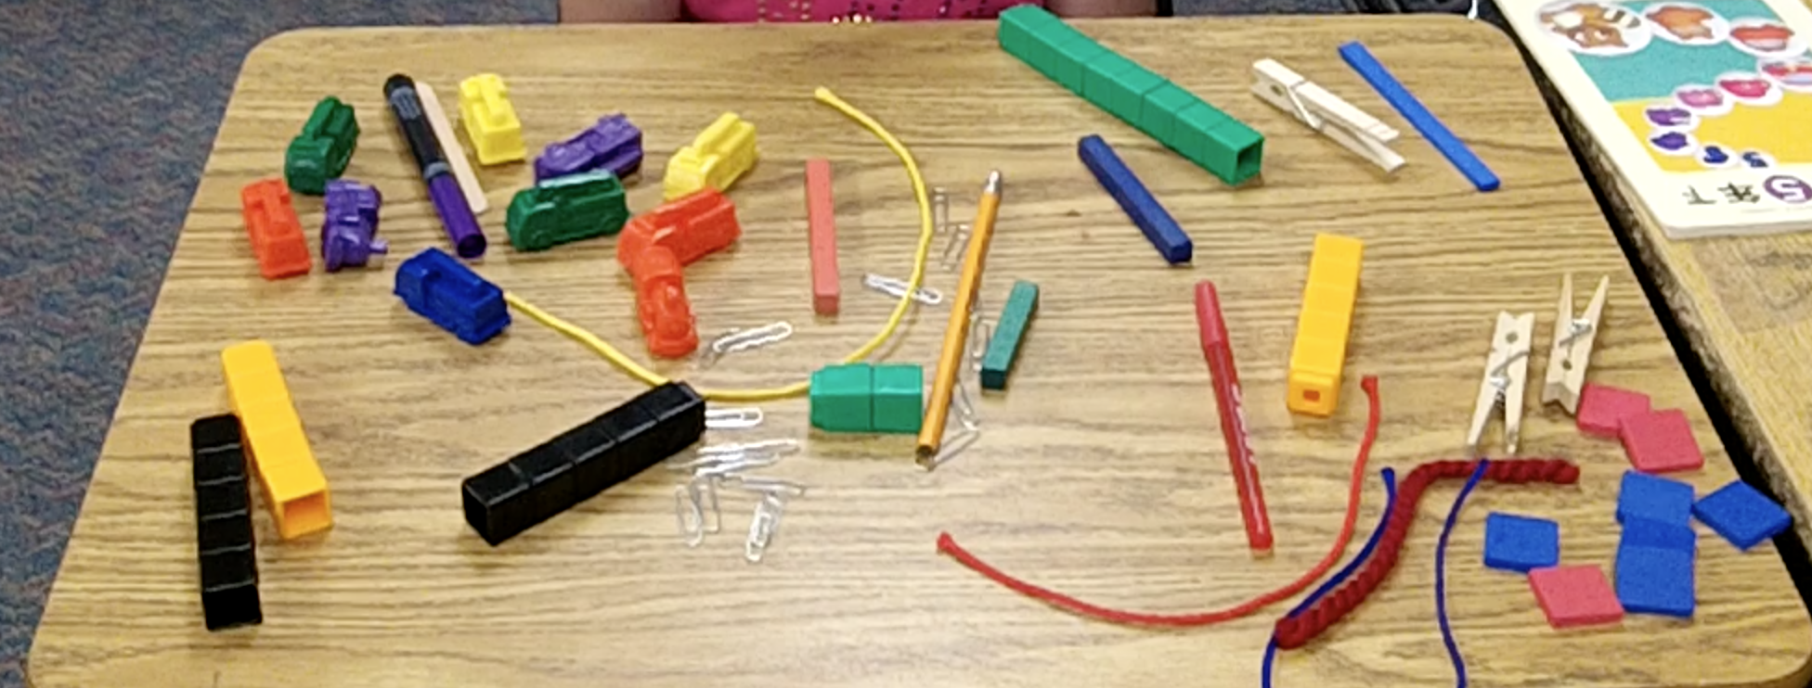

1. **Task for Direct Comparison:** *Select two objects close to the same length but not equal in length (we used a Crayola marker and a red pen)*

* Question: Which one is longer? How do you know?

1. **Task for Indirect Comparison:** *Select two other objects close to the same length and a third object that’s between the lengths of the other two (we used a red string and a pencil with 9 connecting cubes as the third object)*

* Question: “Here is a red string and here is a pencil. Let’s pretend they are glued to the table and we need to figure out which one is longer. How can you use this stick of connecting cubes to figure it out?”

1. **Task for End-to-End or Length Unit Relater and Repeater:** *Select an object that is close to an exact number of inches long and provide inch squares (we used a 12” green foam strip and inch squares)*

* “This is 1 inch.” (Show an inch square.) “How can you use this to show me how long this foam strip is?”
* If child does not iterate, have child attempt with two, inch squares. “What if I give you two inch squares? Can you tell me how long the foam strip is?”
* Finally, provide more than enough inch squares to measure the length and ask, “If I give you as many as you need, can you tell me how long the foam strip is?” or “…, can you check your answer?”
* After child has laid out units end-to-end successfully, replace 4, inch squares with 2 other objects that fit into the space to see if child recognizes the need for equal units when measuring.

1. **Task for Length Unit Relater and Repeater and above**: This is a broken ruler with some numbers missing. What number should go in the place of this question mark?

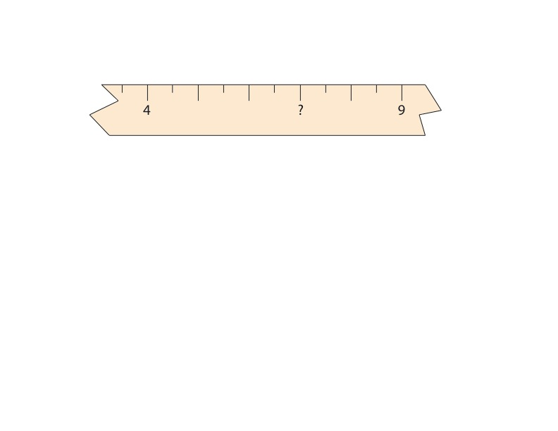

1. **Broken Ruler Task:**



* Show child the picture above. Say, “This is a picture of a rod just below a broken section of a ruler. Use this picture to measure the length of the rod. How long is the rod?”