**Classroom Connection Activity**

Please engage in the following activities and bring resulting responses or materials with you to our next session. Feel free to engage with colleagues in these activities; however, it will be helpful for each participant to (bring or upload) responses and materials for our next session.

1) Use a length measurement task that would support the learning of the students you assessed in your last CCA. You could use the task with a few individual students OR you could try using with your whole class. Feel free to use the task that you analyzed with your colleagues in the last session or to select a different from your curriculum that you feel will be more generative.

1. Use the anecdotal notes form to support your thinking about how the task will allow you to see students’ knowledge and skills with respect to particular learning trajectory levels.
2. Facilitate students’ engagement in the task.
3. As students work try taking notes in the notetaking form about how students engage in the task. Try to connect what you see with a learning trajectory level (or more than one if it seems more fitting).
4. Bring the task you used and your notes to our next session when you will have a chance to share them with a small group of your colleagues.

2) Our next three sessions will focus on the measurement of area. Begin looking for an example lesson or activity from your curriculum that could be used to support learning about area. For our purposes it doesn’t have to be an activity that you think is particularly strong, but rather just a sample from your curriculum. You won’t need to bring this to our next session.

*Setup:* Place several objects of different lengths on the table. Refer child to objects on desk.

Here’s an example of what we used: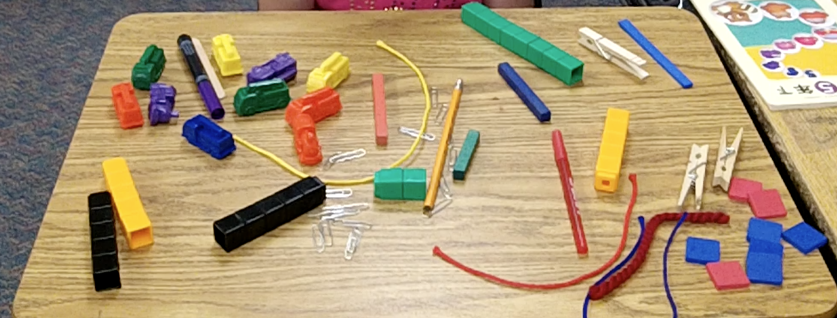

1. **Task for Direct Comparison:** *Select two objects close to the same length but not equal in length (we used a Crayola marker and a red pen)*

* Question: Which one is longer? How do you know?

1. **Task for Indirect Comparison:** *Select two other objects close to the same length and a third object that’s between the lengths of the other two (we used a red string and a pencil with 9 connecting cubes as the third object)*

* Question: “Here is a red string and here is a pencil. Let’s pretend they are glued to the table and we need to figure out which one is longer. How can you use this stick of connecting cubes to figure it out?”

1. **Task for End-to-End or Length Unit Relater and Repeater:** *Select an object that is close to an exact number of inches long and provide inch squares (we used a 12” green foam strip and inch squares)*

* “This is 1 inch.” (Show an inch square.) “How can you use this to show me how long this foam strip is?”
* If child does not iterate, have child attempt with two, inch squares. “What if I give you two inch squares? Can you tell me how long the foam strip is?”
* Finally, provide more than enough inch squares to measure the length and ask, “If I give you as many as you need, can you tell me how long the foam strip is?” or “…, can you check your answer?”
* After child has laid out units end-to-end successfully, replace 4, inch squares with 2 other objects that fit into the space to see if child recognizes the need for equal units when measuring.

1. **Task for Length Unit Relater and Repeater and above**: This is a broken ruler with some numbers missing. What number should go in the place of this question mark?

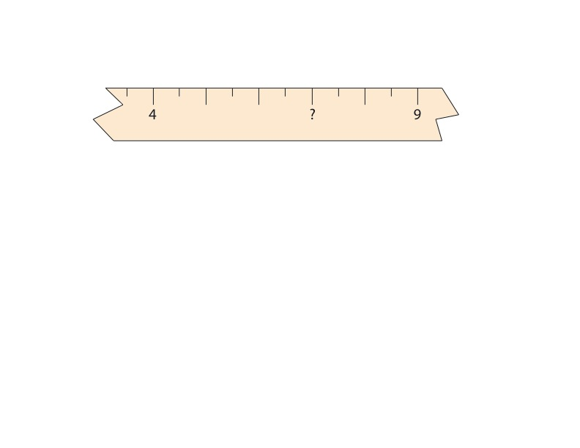

1. **Broken Ruler Task:**



Show child the picture above. Say, “This is a picture of a rod just below a broken section of a ruler. Use this picture to measure the length of the rod. How long is the rod?”