**Classroom Connection Activity**

Please engage in the following activities and bring resulting responses or materials with you to our next session. Feel free to engage with colleagues in these activities; however, it will be helpful for each participant to (bring or upload) responses and materials for our next session.

1. Begin looking through your curriculum and assessments to locate examples that focus on measuring area. We will ask you to bring these examples to session 6 when we discuss the connection of instruction to the area learning trajectory.
2. Try the following area conservation task with 3 students in your classroom. Video record the students doing the task and any interactions you have with the students so that you can think more about what they are doing and thinking. If there is time and if it seems appropriate, you may want to try the task variation or one or more of the alternate tasks on the following pages. Be ready to discuss what you learn with a small group at the start of our next session. Feel free to bring your video to share with your colleagues.

Materials:

* Two large, green rectangles with the same area (the “farms”)
* Two small, toy cows
* 12 wooden cubes (the “farmhouses”)

Procedure:

* Place the two large, green rectangles (“farms”) on the table in front of the child
* Place one toy cow on each “farm”.
* Ask, “Does each cow have the same amount of grass to eat or does one have more?”
* Place wooden cubes (“farmhouses”) on the “farms” one at a time, alternating between the “farms”; that is, place one cube on the first rectangle, then one on the other. Continue to place cubes in this manner until each “farm” has six “farmhouses” on it.
  + On the first “farm”, place the cubes so the form neat rows and columns.
  + On the second “farm”, place the cubes in a scattered arrangement (see below).
* Ask, “Now does each cow have the same amount of grass to eat or does one cow have more?”

Macintosh HD:Users:dougvandine:Dropbox:Clements Sarama Denver:Cow Pic 1 - Green Grass.ai Macintosh HD:Users:dougvandine:Dropbox:Clements Sarama Denver:Cow Pic 2 - Green Grass.ai

Now does each cow have the same amount of grass to eat or does one cow have more?

Does each cow have the same amount of grass to eat or does one cow have more?

# Task Variation

Materials:

* Two large, white rectangles with the same area (the “farms”)
* Two small, toy cows
* 12 green squares (the “grass”)

Procedure:

* Place the two large, white rectangles on the table in front of the child
* Place one toy cow on each rectangle
* Place six green squares on each cardboard rectangle so they form neat rows and columns (see left image below) and each “farm” is identical.
* Say, “These green squares show the area of grass each cow can eat. Does each of these two cows have the same amount of grass to eat or does one have more?” This is done to establish equality of area.
* Leave the squares on the first “farm” neatly arranged, but move the squares on the second “farm” into a scattered arrangement (see right image below).
* Ask, “Now does each cow have the same amount of grass to eat or does one cow have more?”

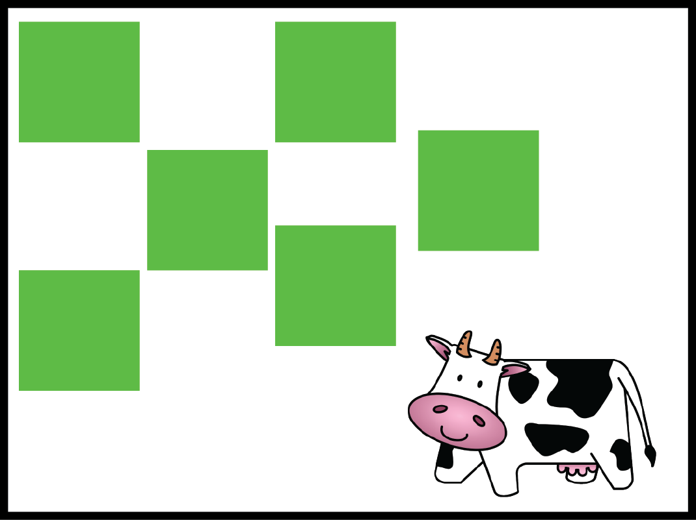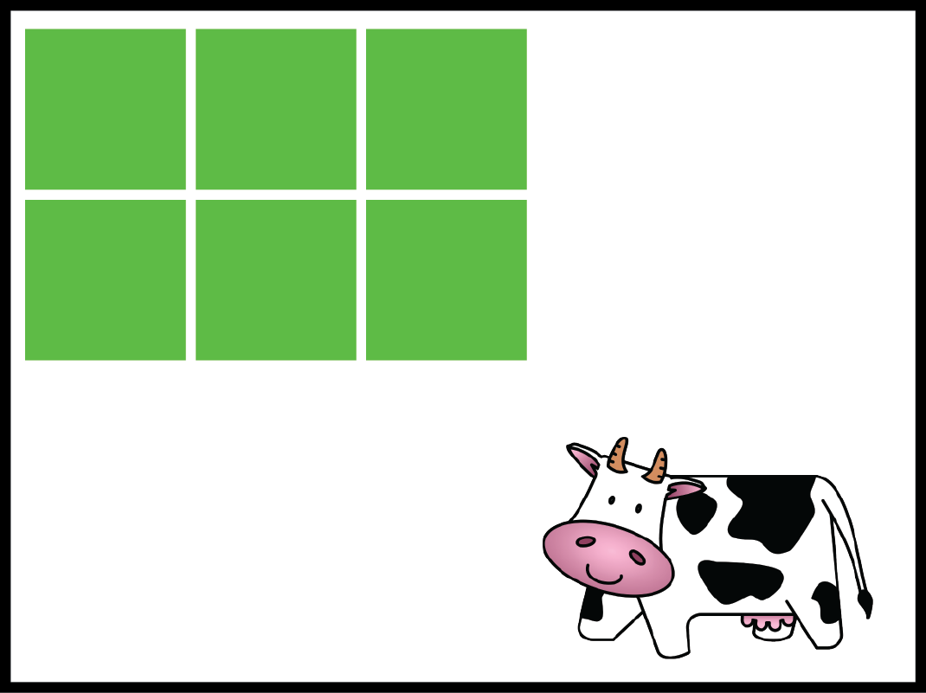

Now does each cow have the same amount of grass to eat or does one cow have more? Does each cow have the same amount of grass to eat or does one cow have more?

Alternate Tasks

Present the following figure to the student and ask him/her to draw a copy on a separate sheet of paper.

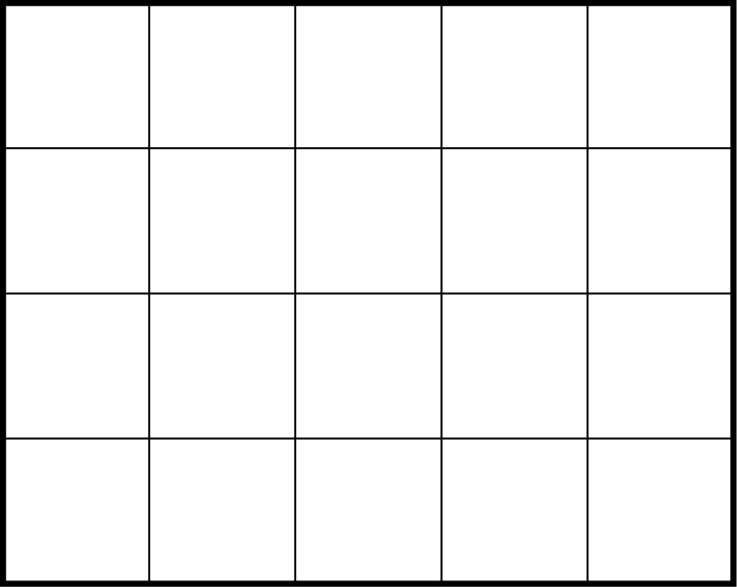

Present the following figure to the student and say, “I wanted to cover this rectangle with these squares. I started drawing them in. Please finish the drawing by completely covering the rectangle.”

