**Classroom Connection Activity**

Please engage in the following activities and bring resulting responses or materials with you to our next session. Feel free to engage with colleagues in these activities; however, it will be helpful for each participant to (bring or upload) responses and materials for our next session.

1) Complete a subset of the tasks on the following pages with 3-4 students of different (hypothesized) achievement levels. The tasks are roughly geared to students in the following grade levels, but you are encouraged to select items that you think will be meaningful for working with your students.

* + Pre-K to Grade 2 - Items 1 through 3
  + Grades 3 and 4 - Items 2 through 4
  + Grades 5 and 6 - Items 4 through 6

1. Use the anecdotal notes form to support your thinking about which task you will use and how it will allow you to see students’ knowledge and skills with respect to particular learning trajectory levels.
2. Administer the tasks. Ask the students to write down and/or draw how they measured.
3. Use the anecdotal notes form to record notes about how students engage in the task*.*
4. In preparation for next session:
   1. Describe the task and the context in which it was used (e.g., grade, reason for selecting this particular student, etc.)
   2. Respond to the following focus questions, with references to specific things the students did and/or said, if possible.
      * How did or could the learning trajectory provide a framework for understanding their responses and strategies? What did it help you notice?
      * What did you see or hear that was consistent (or not) with the ideas in the learning trajectory?
      * How could the learning trajectory help plan “next steps” (formative assessment)?

2) Bring copies of the tasks you used and your notes to our next session where you will have a chance to share them with a small group of your colleagues.

3) For our next session, bring an example lesson or activity from your curriculum that could be used to support learning about length measurement. For our purposes it doesn’t have to be an activity that you think is particularly strong, but rather just a sample from your curriculum.

**Assessment Activity Collection**

1. Present the following figure to the student and ask him/her to draw a copy on a separate sheet of paper.

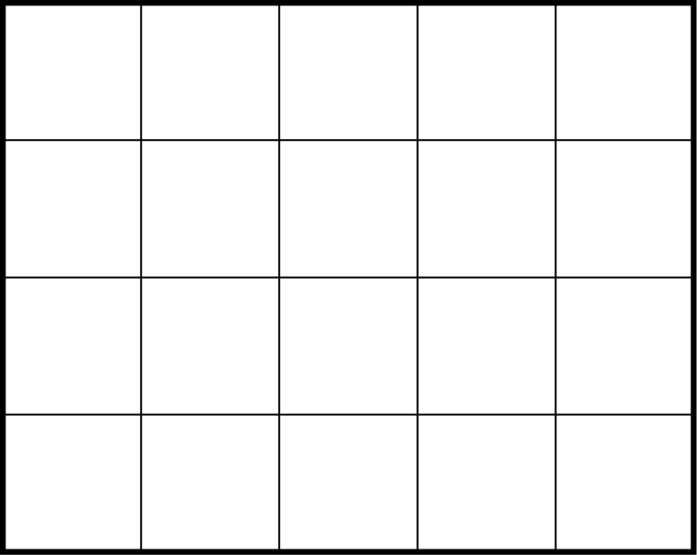

1. Provide the student with a 4 in x 6 in rectangle and a pile of square inch tiles. Allow student to place the tiles directly on the rectangle.

“I wanted to cover this rectangle (trace around the boundary of the rectangle) with these squares (point to one of the foam square inch units). Show me how the tiles completely cover the rectangle.”

1. “I wanted to cover this rectangle with these squares [point to the top, left square]. I started drawing them in. Please finish the drawing by completely covering the rectangle.”



1. The area of this rectangle is 10 square inches. Draw how each of the 10 square inches fit.
2. Draw a rectangle that has an area of 8 square inches. You may use a ruler to help you. Show on your rectangle how the 8 square inches fit.
3. How many of the small rectangles would it take to cover the large rectangle?

