**Classroom Connection Activity**

Please engage in the following activities and bring resulting responses or materials with you to our next session. Feel free to engage with colleagues in these activities; however, it will be helpful for each participant to (bring or upload) responses and materials for our next session.

1) Use a area measurement task that would support the learning of the students you assessed in your last CCA (examples are provided on the following pages). You could use the task with a few individual students OR you could try using with your whole class. Feel free to use the task that you analyzed with your colleagues in the last session or to select a different from your curriculum that you feel will be more generative.

1. Use the anecdotal notes form to support your thinking about how the task will allow you to see students’ knowledge and skills with respect to particular learning trajectory levels.
2. Facilitate students’ engagement in the task.
3. As students work, try using the notetaking form to capture how students engage in the task. Try to connect what you see with a learning trajectory level (or more than one if it seems more fitting).
4. Bring the task you used and your notes to our next session when you will have a chance to share them with a small group of your colleagues.

2) Our next three sessions will focus on the measurement of volume. Begin looking for an example lesson or activity from your curriculum that could be used to support learning about volume. For our purposes it doesn’t have to be an activity that you think is particularly strong, but rather just a sample from your curriculum. You won’t need to bring this to our next session.

**Assessment Activity Collection**

1. Present the following figure to the student and ask him/her to draw a copy of this on a separate sheet of paper.

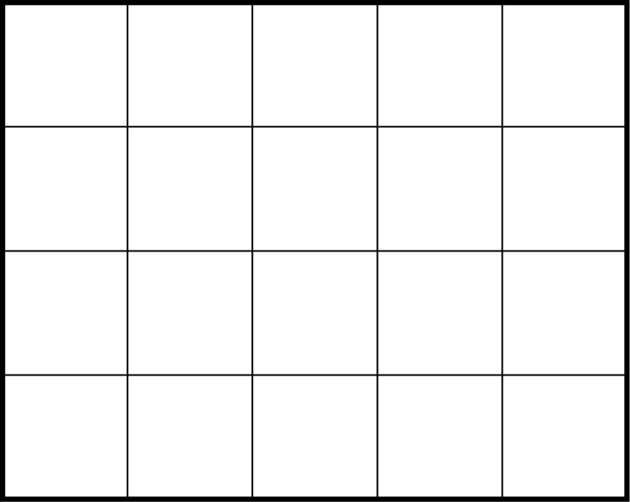

1. Provide the student with the 4 in x 6 in rectangle and a pile of square inch tiles. Allow student to place the tiles directly on the rectangle.

“I wanted to cover this rectangle (trace around the boundary of the larger rectangle) with these squares (point to one of the foam square inch units). Show me how the tiles completely cover the rectangle.”

1. “I wanted to cover this rectangle with these squares. I started drawing them in. Please finish the drawing by completely covering the rectangle.”



1. The area of this rectangle is 10 square inches. Draw how each of the 10 square inches fit.
2. Draw a rectangle that has an area of 8 square inches. You may use a ruler to help you. Show on your rectangle how the 8 square inches fit.
3. How many of the small rectangles would it take to cover the large rectangle?

