**Classroom Connection Activity**

Please engage in the following activities and bring resulting responses or materials with you to our next session. Feel free to engage with colleagues in these activities; however, it will be helpful for each participant to (bring or upload) responses and materials for our next session.

1. Begin looking through your curriculum and assessments to locate examples that focus on measuring volume. We will ask you to bring these examples to session 9 when we discuss the connection of instruction to the volume learning trajectory.
2. Try some of the following volume tasks with 2 or 3 students in your classroom. Video record the students doing the task and any interactions you have with the students so that you can think more about what they are doing and thinking. Be ready to discuss what you learn with a small group at the start of our next session. Feel free to bring your video to share with your colleagues.

Materials:

* Copies of the volume tasks on the following pages
* 24 Cubes

1. Place the 2 x 3 x 2 prism on the table and give the students 24 cubes. Then say, “Please put some cubes together to make a block that has the same volume as this block.”

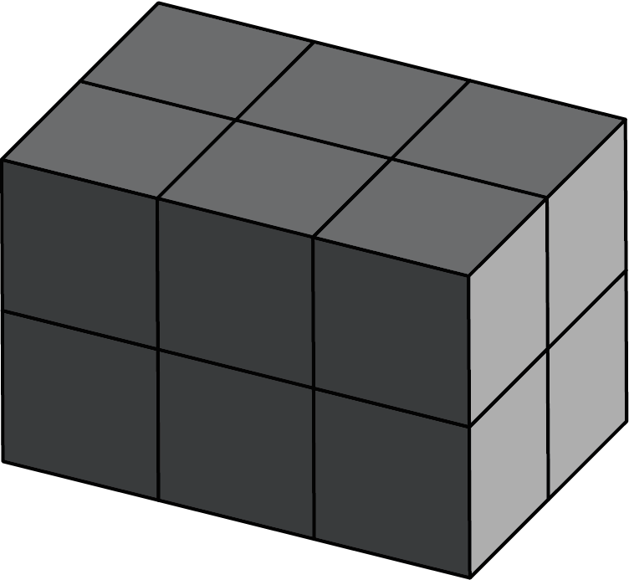

Alternative questions (focusing on having students count the cubes):

1. How many blocks would I need to make a block exactly like this?
2. How many cubes are in this block?
3. Show the pictures below and say, “The graduated cylinder is marked in units the same size as one of these cubes. If I fill the cylinder tot he 12th mark with sand, which of these boxes would hold that same amount of sand? How do you know”

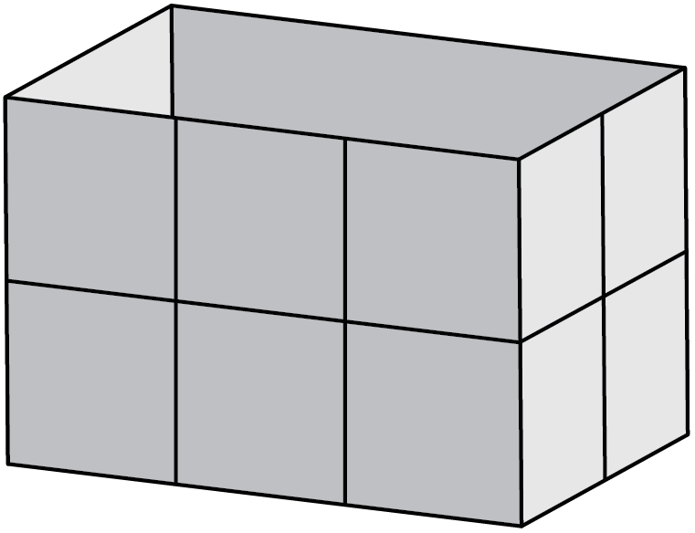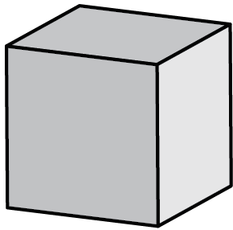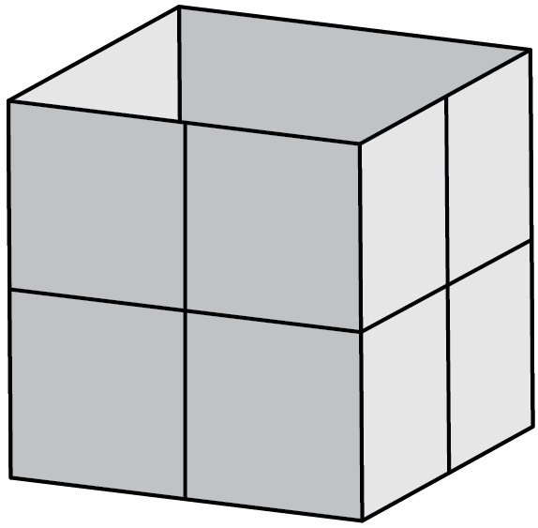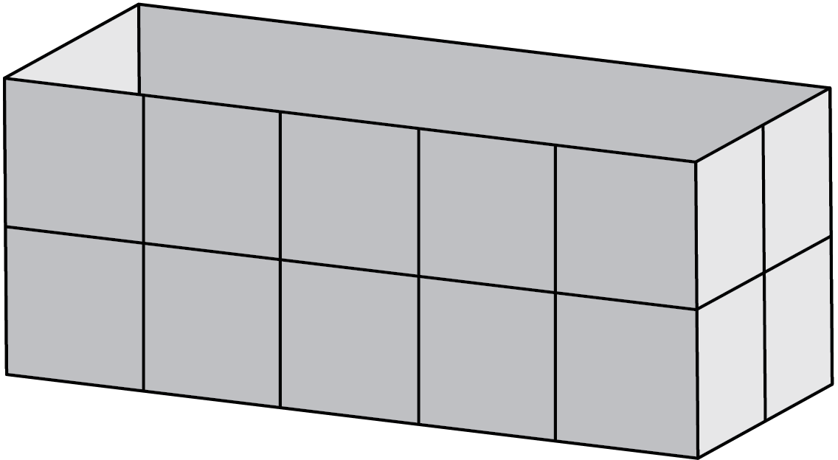

14

13

12

11

10

9

8

7

6

5

4

3

2

1

1. Show the picture of the partially-filled box below. Ask, “How many cubes would it take to fill the box?”

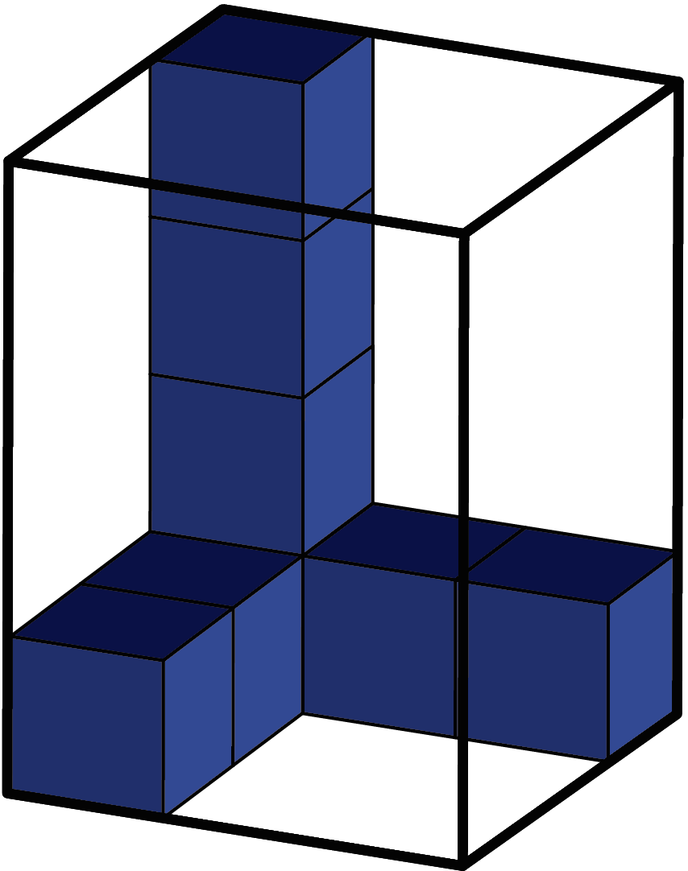

1. Show the picture below. Then ask, “This pattern is used to make a box without a top. If we make this box, how many cubes will it take to completely fill it?” Make sure to clarify that the faces of the cubes are exactly the same as the squares in the pattern.

|  |  |  |  |  |  |  |  |  |
| --- | --- | --- | --- | --- | --- | --- | --- | --- |
|  | |  |  |  |  |  |  | |
|  |  |  |  |  |
|  |  |  |  |  |  |  |  |  |
|  |  |  |  |  |  |  |  |  |
|  |  |  |  |  |  |  |  |  |
|  | |  |  |  |  |  |  | |
|  |  |  |  |  |