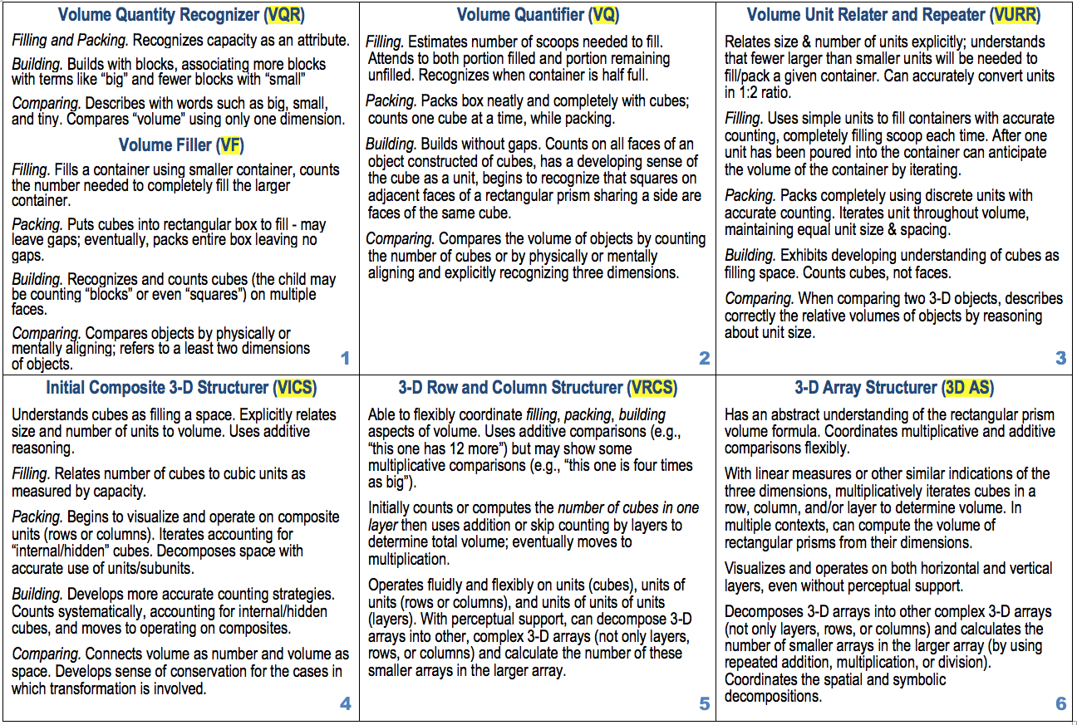

|  |  |  |  |  |  |
| --- | --- | --- | --- | --- | --- |
| **Date:** |  | | | **Time:** |  |
|  |  | | |  |  |
| **Tasks** | | | | | |
| **Focal Learning Trajectories (based on task analysis and what you’ve learned about your students)** | | | | | |
| **Class Roster** | | **LT code** | **Evidence (Notes/Images)** | | |
|  | |  |  | | |
|  | |  |  | | |
|  | |  |  | | |
|  | |  |  | | |
|  | |  |  | | |
|  | |  |  | | |