**Classroom Connection Activity**

Please engage in the following activities and bring resulting responses or materials with you to our next session. Feel free to engage with colleagues in these activities; however, it will be helpful for each participant to (bring or upload) responses and materials for our next session.

1) Complete a subset of the tasks on the following pages with 3-4 students of different (hypothesized) achievement levels. The tasks are organized sequentially, starting with tasks that target early levels in the volume learning trajectory and ending with tasks that target later levels in the trajectory. You are encouraged to select items that you think will be meaningful for working with your students.

1. Use the anecdotal notes form to support your thinking about which task you will use and how it will allow you to see students’ knowledge and skills with respect to particular learning trajectory levels.
2. Administer the tasks. Ask the students to write down and/or draw how they measured.
3. Use the anecdotal notes form to record notes about how students engage in the task*.*
4. In preparation for next session:
   1. Describe the task and the context in which it was used (e.g., grade, reason for selecting this particular student, etc.)
   2. Respond to the following focus questions, with references to specific things the students did and/or said, if possible.
      * How did or could the learning trajectory provide a framework for understanding their responses and strategies? What did it help you notice?
      * What did you see or hear that was consistent (or not) with the ideas in the learning trajectory?
      * How could the learning trajectory help plan “next steps” (formative assessment)?

2) Bring copies of the tasks you used and your notes to our next session where you will have a chance to share them with a small group of your colleagues.

3) For our next session, bring an example lesson or activity from your curriculum that could be used to support learning about volume measurement. For our purposes it doesn’t have to be an activity that you think is particularly strong, but rather just a sample from your curriculum.

**Assessment Activity Collection**

1. Find two containers of slightly different volumes. As you point to the containers) say, *“Pay attention because I am going to ask you a question about these two containers.”*

Then completely fill the smaller container with water or sand. Pour the sand/water from the smaller container into the larger container.

Finally ask, *“Which of these two containers can hold more sand/water? Why do you think that one holds more?”*

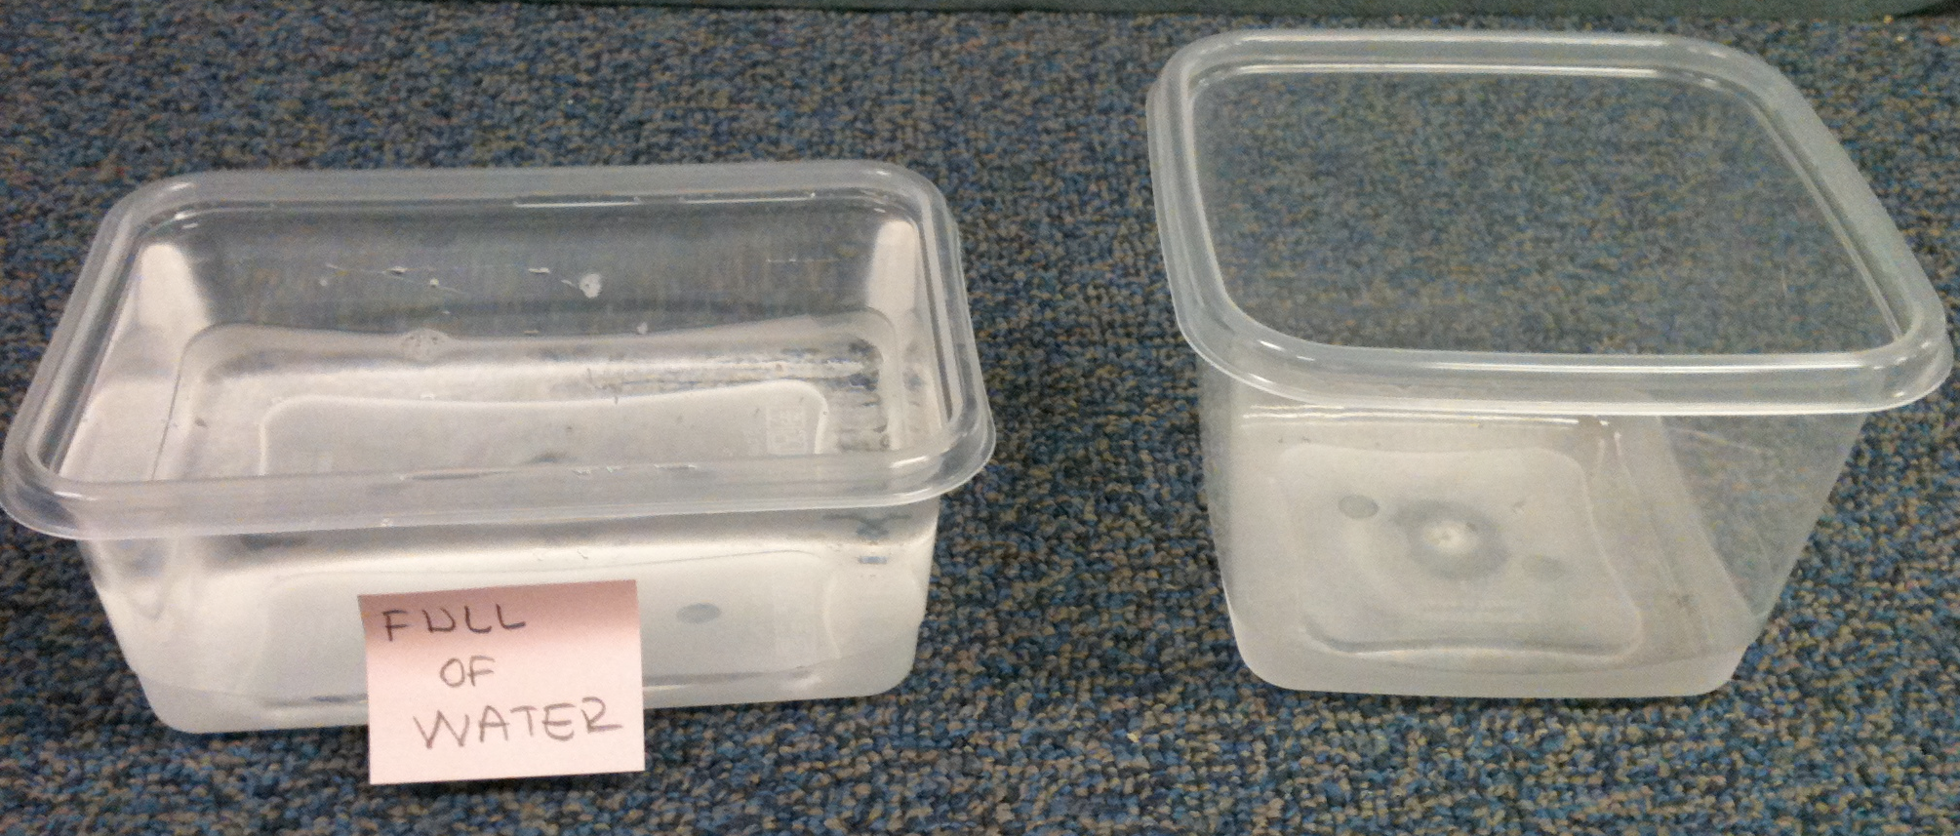

1. Place the 2 x 3 x 2 prism on the table and give the students 24 cubes. Then say, “Please put some cubes together to make a block that has the same volume as this block.”
2. Place the 2 x 3 x 2 prism on the table and give the students 24 cubes. Then ask, “How many cubes would I need to make a block exactly like this? (Alternatively: How many cubes are in this block?)
3. Show the picture of the partially-filled box below. Ask, “How many cubes would it take to fill the box?”

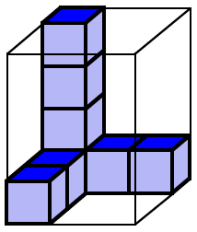

1. Show the pictures below and say, “The graduated cylinder is marked in units the same size as one of these cubes. If I fill the cylinder to the 12th mark with sand, which of these boxes would hold that same amount of sand? How do you know”

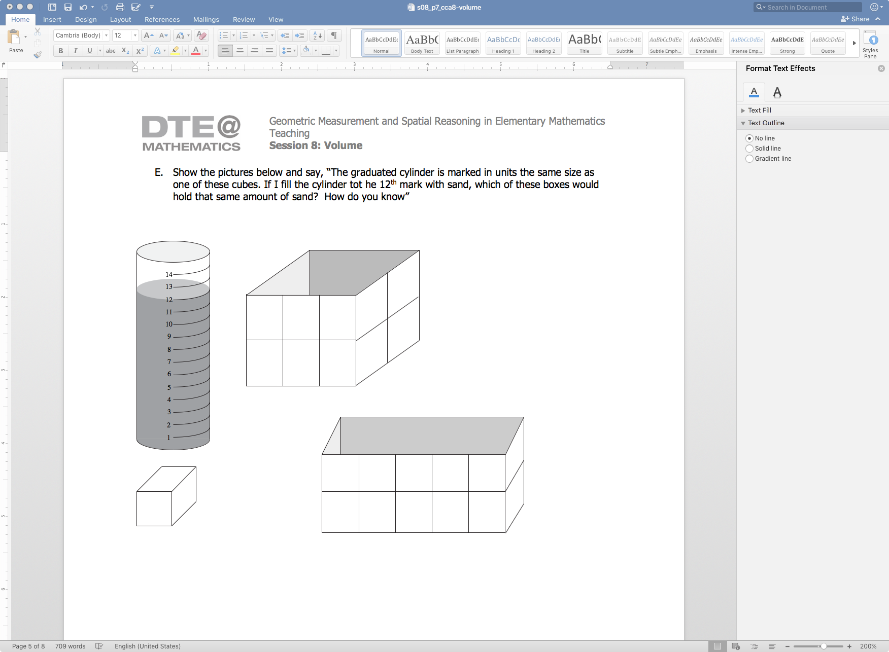 

14

13

12

11

10

9

8

7

6

5

4

3

2

1

1. Show the picture below. Then ask, “This pattern is used to make a box without a top. If we make this box, how many cubes will it take to completely fill it?” Make sure to clarify that the faces of the cubes are exactly the same as the squares in the pattern.

|  |  |  |  |  |  |  |  |  |
| --- | --- | --- | --- | --- | --- | --- | --- | --- |
|  | |  |  |  |  |  |  | |
|  |  |  |  |  |
|  |  |  |  |  |  |  |  |  |
|  |  |  |  |  |  |  |  |  |
|  |  |  |  |  |  |  |  |  |
|  | |  |  |  |  |  |  | |
|  |  |  |  |  |

1. Show the picture below. Then say, *“Maria has some packages that each contain two identical cubes. She wants to know how many of these packages it takes to completely fill the rectangular box below.”*

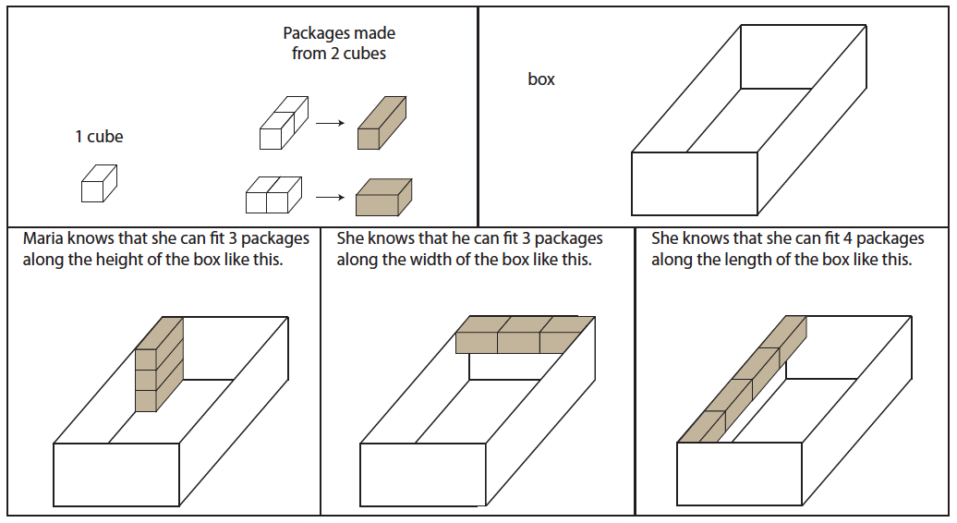

1. Show the picture below. They say, *“The cube on the left has a volume of one cubic meter. What is the volume of the rectangular prism on the right?”*

