**Classroom Connection Activity**

Please engage in the following activities and bring resulting responses or materials with you to our next session. Feel free to engage with colleagues in these activities; however, it will be helpful for each participant to (bring or upload) responses and materials for our next session.

1) Use a measurement activity with your whole class. It could focus on length, area, or volume. It could be an activity from your curriculum or an activity that you have been thinking about from our sessions – like one of the volume measurement tasks from your last CCA (examples are provided on the following pages).

1. Video record the activity
2. Also use the anecdotal notes form most appropriate to the content of the activity (length, area, or volume) to support your thinking about how the task will allow you to see students’ knowledge and skills with respect to particular learning trajectory levels.
3. Facilitate students’ engagement in the task.
4. As students work, try using the notetaking form to capture how students engage in the task. Try to connect what you see with a learning trajectory level (or more than one if it seems more fitting).
5. Bring the task you used, your video, and your notes to our next session when you will have a chance to share them with a small group of your colleagues.

2) The next session is our last session in this professional development series. Prior to coming to the session, please reflect on the work you have done and the ideas that are you taking from our work together. What are some “big ideas” in measurement that you are taking away from this experience? What are some meaningful connections that are you are seeing across measurements of length, area, and volume? How are you thinking about students as learners of measurement and/or the teaching of measurement? Bring your ideas to the session. Together we will try to make connections as we summarize the work we have done together and think about how harness it moving forward.

**Assessment Activity Collection**

1. Find two containers of slightly different volumes. As you point to the containers) say, *“Pay attention because I am going to ask you a question about these two containers.”*

Then completely fill the smaller container with water or sand. Pour the sand/water from the smaller container into the larger container.

Finally ask, *“Which of these two containers can hold more sand/water? Why do you think that one holds more?”*

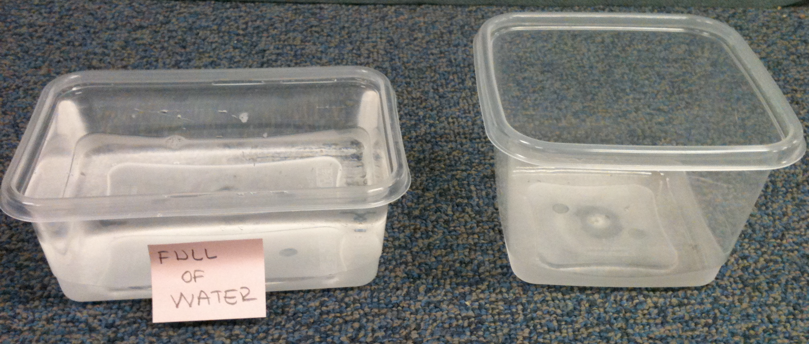

1. Place the 2 x 3 x 2 prism on the table and give the students 24 cubes. Then say, “Please put some cubes together to make a block that has the same volume as this block.”
2. Place the 2 x 3 x 2 prism on the table and give the students 24 cubes. Then ask, “How many cubes would I need to make a block exactly like this? (Alternatively: How many cubes are in this block?)
3. Show the picture of the partially-filled box below. Ask, “How many cubes would it take to fill the box?”

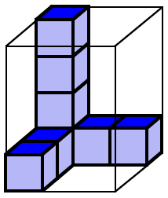

1. Show the pictures below and say, “The graduated cylinder is marked in units the same size as one of these cubes. If I fill the cylinder to the 12th mark with sand, which of these boxes would hold that same amount of sand? How do you know”

14

13

12

11

10

9

8

7

6

5

4

3

2

1

1. Show the picture below. Then ask, “This pattern is used to make a box without a top. If we make this box, how many cubes will it take to completely fill it?” Make sure to clarify that the faces of the cubes are exactly the same as the squares in the pattern.

|  |  |  |  |  |  |  |  |  |
| --- | --- | --- | --- | --- | --- | --- | --- | --- |
|  | |  |  |  |  |  |  | |
|  |  |  |  |  |
|  |  |  |  |  |  |  |  |  |
|  |  |  |  |  |  |  |  |  |
|  |  |  |  |  |  |  |  |  |
|  | |  |  |  |  |  |  | |
|  |  |  |  |  |

1. Show the picture below. Then say, *“Maria has some packages that each contain two identical cubes. She wants to know how many of these packages it takes to completely fill the rectangular box below.”*

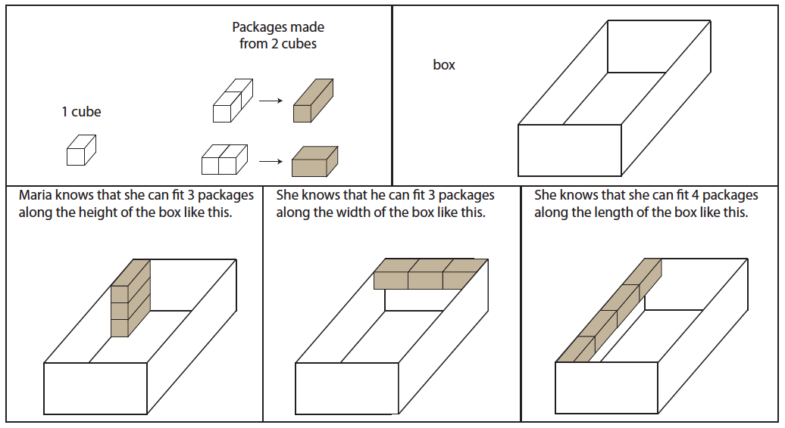

1. Show the picture below. They say, *“The cube on the left has a volume of one cubic meter. What is the volume of the rectangular prism on the right?”*

