**Classroom Connection Activity**

Please engage in the following activities and bring the indicated responses or materials to our next session. Feel free to engage with colleagues in these activities; however, it will be helpful for each participant to (bring or upload) responses and materials for the next session.

1. *Working on reasoning with your students*

In your classroom, spend 15-20 minutes working with your students on the problem that corresponds to your grade level. The problems can be modified as needed to fit your classroom. Video record the entire activity to support your reflection. In a later session, you will also view and consider a short segment of this video with colleagues. If students produce written work, collect student work samples (5-6 examples that represent a range in student reasoning).

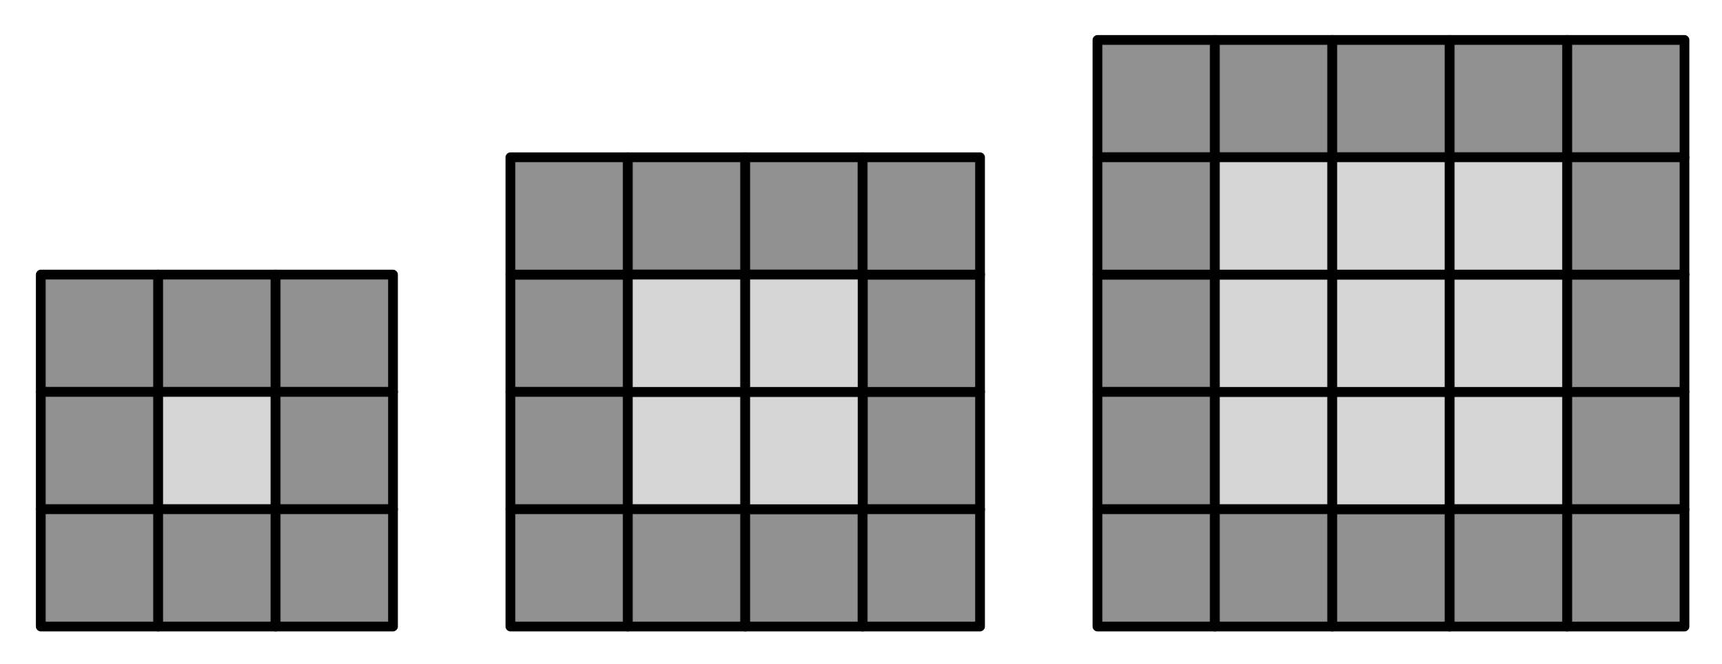For kindergarten, first, and second-grade classrooms, pose these questions:

*Mr. Supersquare is building patterns. He makes a square with yellow tiles. The first one has just one tile. The second one is made out four tiles. The third one has nine tiles.*

[Make sure that the students see the yellow squares built out of yellow tiles.]

*1st square 2nd square 3rd square*

*with border with border with border*

*Then he builds a border all the way around the yellow square. How many tiles does it take to build the border around the first square? How many tiles does it take to build the border around the second square? How about the third? How many tiles will it take to build the next square after the one with 9 tiles?*

[(16) Have students explain how they arrive at the total of 16.]

*Can you figure out how many tiles it will take to put a border all the way around that square?*

[(20) Have the students build it and then explain.]

*Show the one with 25 tiles and ask, “Can you figure out how many tiles it will take to put a border all the way around that square?”*

[(24) Have the students build it and then explain and prompt the students to see if there are different ways to explain how to arrive at the total.]

For third, fourth, and fifth-grade classrooms, pose these questions:

*Maria is designing square swimming pools. Each pool has a square center where the water is and a border of square tiles. Here are pictures of three square pools she can design with square tiles for the border.*

*How many square tiles does it take to build a border around a square “pool?”*

*Find a way to know the number of tiles it will take without having to count, for any size pool.*

[Encourage your students to share the patterns, conjectures, and questions they have as they explore this problem. Students can use tiles if desired.]

1. *Beginning to prepare for the video workshop that will happen in Session 4*
   1. Watch your video.
   2. Record your responses to the following reflection questions.
      1. How are students supporting/explaining their approaches using words, drawings, and/or tools?
      2. What student strategies, solutions, or questions did you find interesting? Why?
      3. What teaching moves are you using to establish and maintain an environment that nurtures student reasoning practices?

**Optional**

1. Read the “Pool Border Problem” Math Notes document. Consider:
   1. example approaches that you had not yet considered or seen;
   2. the connection between specific examples and a generalized expression;
   3. which mathematical practice seems most strongly connected to this problem. Try describing why this connection is stronger than others.
2. Read the short article “Viewing teaching on videotape” by Miriam Sherin (2000) to support your thinking about the purposes and benefits of studying videos of teaching with colleagues. We will discuss points from this short article at our next session.